新疆农垦学院（平台是张家口公司）球阀
联系人（销售）张嘉英 13345464257

平台问：
平台地址：https://www.sshyun.com
账号：liurunyu
密码：12345678

系统设置
开发者ID:
f34e4ac6be4441a6b7d13790313f22d0
开发者密码：
b691aef23bf944599963786862370346

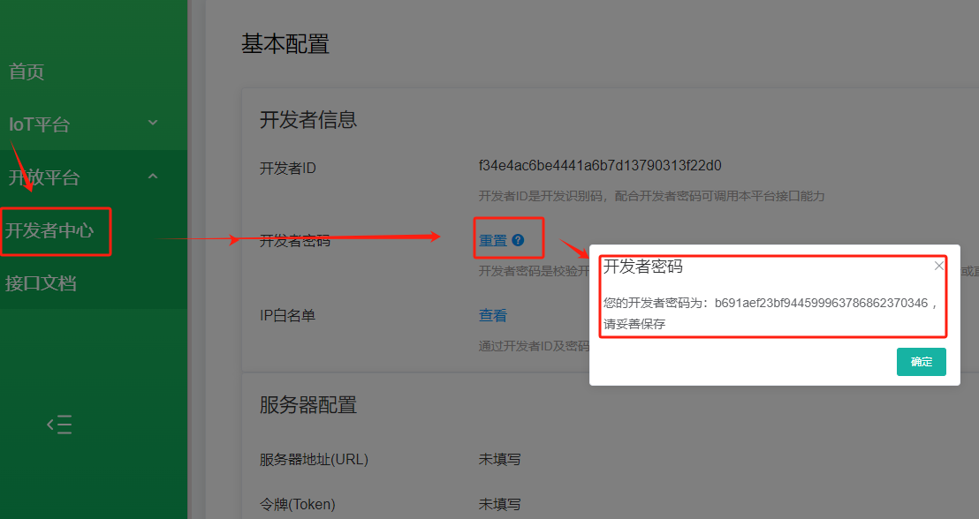
IP白名单
百度查询
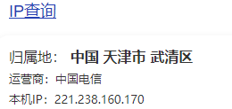
系统设置
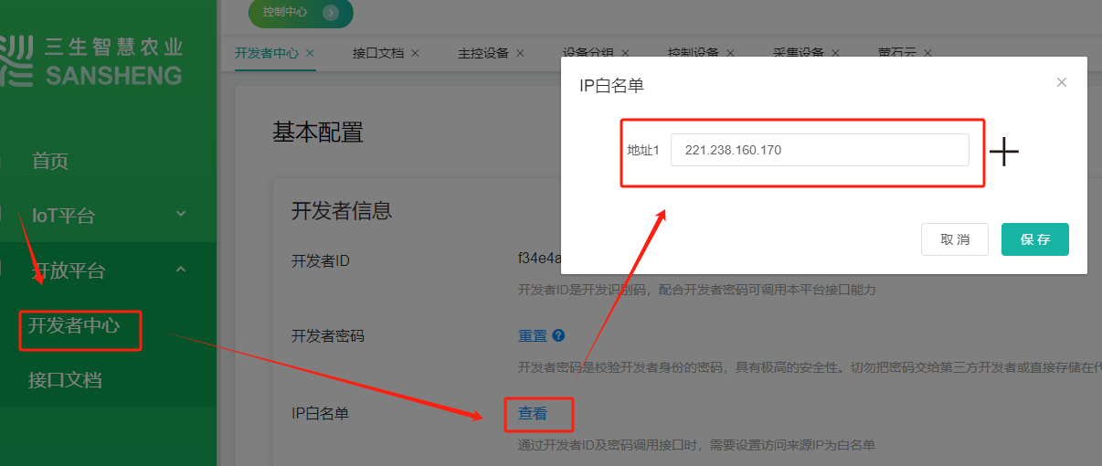

接口测试

获得access_token
- URL：https://www.sshyun.com/thirdapi/token?appid=*****&secret=****
- 参数：无
- 返回：
成功
Status Code: 200
Response encoding: application/json;charset=UTF-8
Response Body: {
"accessToken":"090ae83ea9347c1f928674093fe27492c7fe91f2b625221fc90a3246394e4b748841d3c062ccece14ac40708374b1a12",
"expires":7200
}
出错
Status Code: 200
Response encoding: text/plain;charset=ISO-8859-1
Response Body: {"errcode":10000,"errmsg":"appid or secret error"}

获取主控器
- URL：https://www.sshyun.com/thirdapi/pridevice/all?access_token=****
- 参数：无
- 返回：
Status Code: 200
Response encoding: UTF-8
Response Body: [
{
"channel":"1",
"deviceid":"sanfangceshipingtai",
"id":393,
"lat":0.0,
"lng":0.0,
"mode":"virtual",
"name":"三方对接测试平台",
"panid":"1",
"sort":0
}
]

获取控制器
- URL：https://www.sshyun.com/thirdapi/control_device/query?access_token=****
- 参数：
Map<String, String> params = new HashMap<>() ;
params.put("pdId", "393") ;
- 返回：
Status Code: 200
Response encoding: UTF-8
Response Body: [
{
"code":"ceshictl",
"ctId":5,
"groupId":0,
"iccid":"ceshictl",
"id":33527,
"lat":0.0,
"lng":0.0,
"mode":"gprs",
"name":"测试水泵",
"pdId":393,
"sort":0
},
{
"code":"L27010000066030",
"ctId":27,
"groupId":0,
"iccid":"L27010000066030",
"id":32195,
"lat":0.0,
"lng":0.0,
"mode":"gprs",
"name":"阀-66030",
"pdId":393,
"sort":57
},
{
"code":"L27010000065899",
"ctId":27,
"groupId":0,
"iccid":"L27010000065899",
"id":31758,
"lat":0.0,
"lng":0.0,
"mode":"gprs",
"name":"阀-65899-测试2",
"pdId":393,
"sort":108
},
{
"code":"L27010000065891",
"ctId":27,
"groupId":0,
"iccid":"L27010000065891",
"id":31750,
"lat":0.0,
"lng":0.0,
"mode":"gprs",
"name":"阀-65891-测试1",
"pdId":393,
"sort":100
},
{
"code":"v0000000000000000005",
"ctId":3,
"groupId":0,
"iccid":"v0000000000000000005",
"id":2512,
"lat":0.0,
"lng":0.0,
"mode":"gprs",
"name":"测试阀门",
"pdId":393,
"sort":0
}
]

远程控制
- URL：https://www.sshyun.com/thirdapi/pridevice/command?access_token=****
- 参数：
Map<String, String>params = new HashMap<>() ;
params.put("classify", "1") ;
params.put("code", "v0000000000000000005") ;
params.put("pdId", "393") ;
params.put("category", "C") ;
params.put("type", "3") ;
params.put("onoff", "0") ;
- 返回：
Status Code: 200
Response encoding: UTF-8
Response Body: "{\"errcode\":-1,\"errmsg\":\"unknown error\"}"

